All Wales Ministers’ Conference 2022
7th- 8th February 2022
Waterfront Church, Langdon Road, Swansea, SA1 8QY

We plan to gather in Swansea for two days of teaching and retreat, with Helen Paynter, Andy Percey and John Archer

Our provisional programme

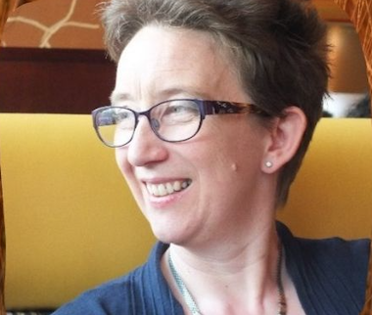
Monday 7th February
10.30 Arrival tea and coffee
11.00 Opening devotions with the Chaplain, Andy Percey
11.30 Session 1 from Helen Paynter

12.30 Lunch

14.00 Workshops/ Updates/Walk/Time with the Chaplain
15.00 Tea and Coffee
15.30 Session 2 from Helen Paynter & closing devotions
17.30 Meal
19.30 Evening Entertainment with John Archer

Tuesday 8th February

9.30 Devotions with Andy Percey
10.00 Workshop or retreat or walk
10.45 Tea & coffee
11.05 Session 3 from Helen Paynter
12.00 Final devotions and communion (Andy Percey)
1.00 Lunch

‘Workshop’ selection includes
BMS World Mission, CYF ministry in times of change, Renew Wellbeing, Forge Missional Training, Retreat resources, Time to pray, Time to walk
Booking Form Please book by December 31st 2021
The conference will cost £65 for the two days, including refreshments, lunches and an evening meal. We ask you to make your own accommodation arrangements. Suggestions are offered on the next page.

Please email booking form to office@swba.org.uk and then pay via BACS, or post to Karen Kaneen, SWBA, 54 Richmond Road, Cardiff, CF24 3UR and enclose a cheque.

Name
Postal Address
Postcode
Contact Numbers
Email
Church Name and Town

Please provide us with information about specific dietary requirements

Payment: If possible, please pay by bank transfer (BACS) and use the minister’s name as a reference. Conference fees are sadly non-refundable apart from in exceptional circumstances.
Account Name: South Wales Baptist Association
Account Number: 00635999
Sort Code: 30-92-49
Otherwise, please send a cheque payable to South Wales Baptist Association

Please tick
I am paying £65 by BACS
I am paying £65 by cheque
I require lunch on Monday 7th February
I require an evening meal on Monday 7th February
I will attend the evening session with John Archer on Monday 7th February
I require lunch on Tuesday 8th February

£65 is the price for the whole conference. In case of difficulty, please contact the BUW or SWBA office. Please let Karen (office@swba.org.uk) know as soon as possible if your requirements, as ticked above, change. Attendance numbers are really important, as we plan to make tickets for the John Archer event available further afield, if there are spaces.
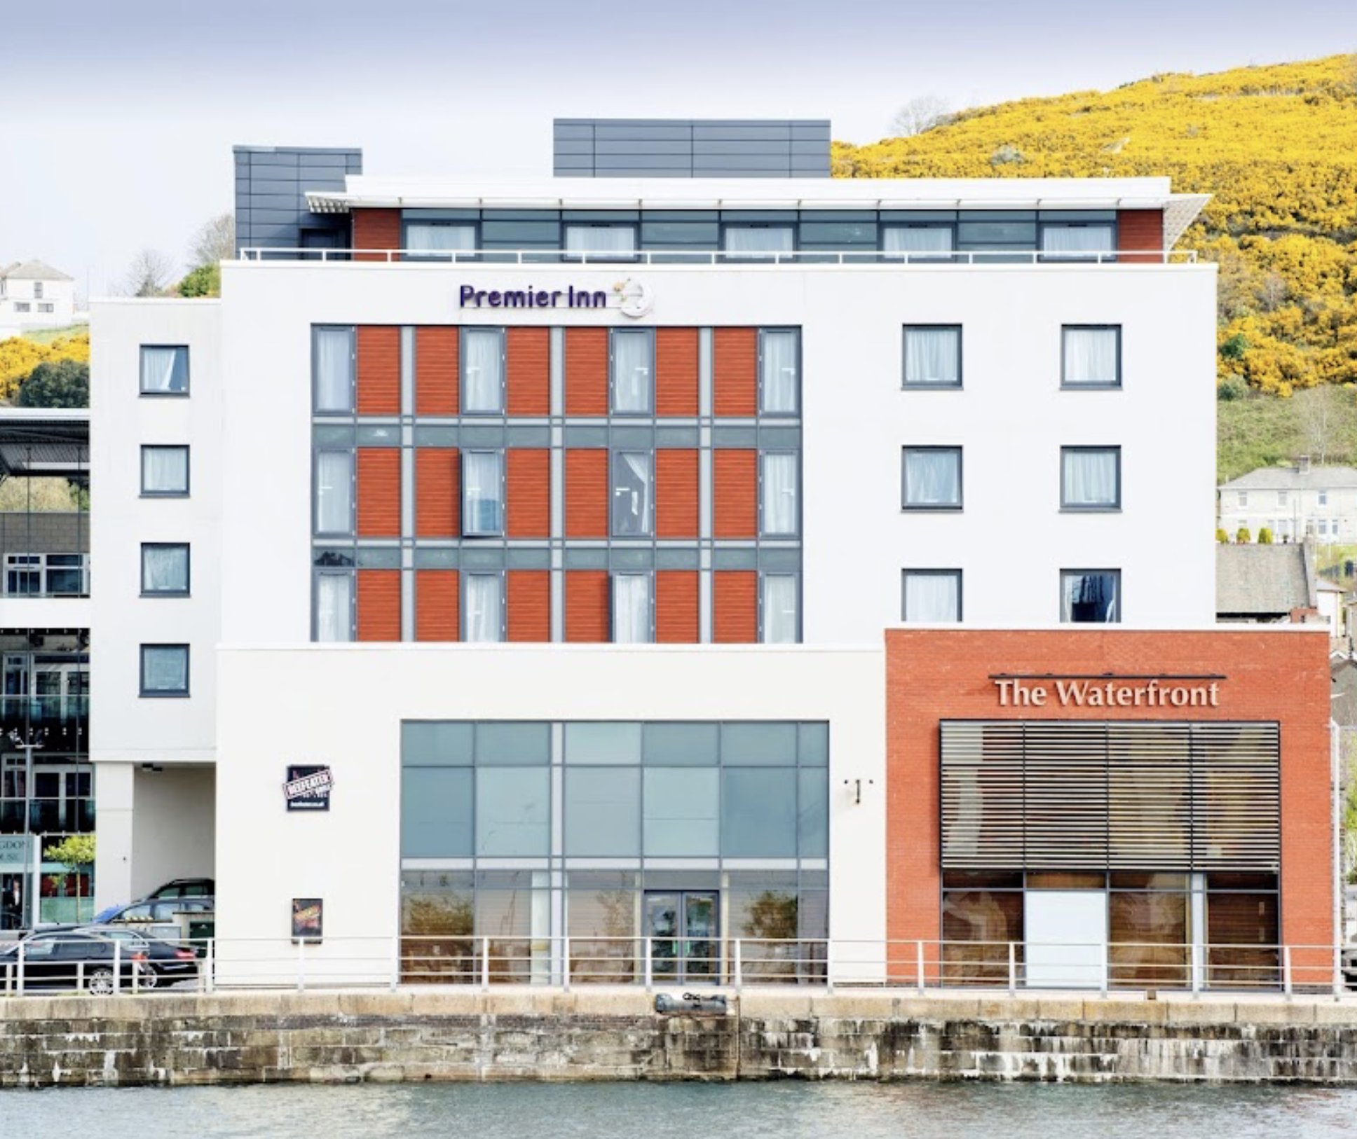 | Premier Inn, 5 minute walk to Waterfront Church  Langdon Road, Swansea SA1 8QY  https://www.premierinn.com/gb/en/hotels/wales/glamorgan/swansea/swansea-waterfront.html?cid=GLBC_SWAWAT  0333 321 9208
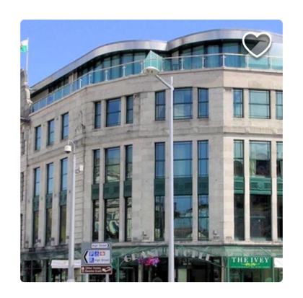 | Grand Hotel, 1 mile to Waterfront Church  Ivey Pl, Swansea SA1 1NX  https://www.thegrandhotelswansea.co.uk  01792 645898
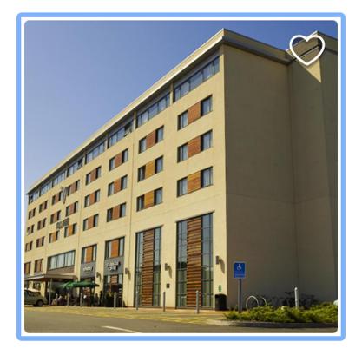 | Village Hotel Swansea, 5 minute walk to Waterfront Church  Langdon Road, Swansea, SA1 8QY  https://www.village-hotels.co.uk/hotels/swansea/  01792 341270
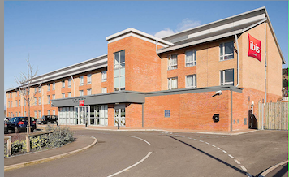 | Ibis Swansea, 1 mile to Waterfront Church  Fabian Way, Swansea SA1 8LD  https://all.accor.com/hotel/6653/index.en.shtml  01792 957020
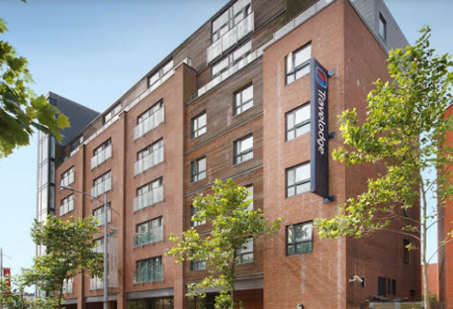 | Travelodge Swansea Central, 1 mile to Waterfront Church  Princess Way, Swansea, SA1 3LQ  Travelodge.co.uk  08719 846326
Accommodation Options near Waterfront Church
Accommodation in Swansea is plentiful, and an internet search will provide many possibilities. We offer a ‘starter list’ with options across the price range.

There is a bus stop about 7 minutes from Swansea railway station in New Cut Road, from where you can catch number 8 bus, descending in Fabian Way, by the Old Police Station. Waterfront Church is a 6 minute walk away.
The church has a very small car park adjoining its premises. Otherwise, there is a large public car park between the Premier Inn and the Waterfront Church. It has a coin-operated parking meeting, or parking may be paid over the phone. At the time of writing charges are: 0-3 hrs £2.40, 3-4 hrs £4.00, 4-12 hrs £5.00, 12-24 hours £6.00.

